Dr. Ralph Steele Provides Vital Input To Gain Financial Freedom
Dr. Ralph Steele offers expert advice on financial freedom and wealth management.
Dr. Ralph Steele, the financial freedom and wealth expert, offers various methods of achieving financial stability. Many individuals, families, and businesses have achieved financial freedom using the advice of Dr. Ralph Steele.

“I specialize in providing financial literacy, social and entrepreneurship training for the growth and expansion of business startups,” says Dr. Ralph Steele about his areas of expertise. “As a structured settlement broker, I conduct estate planning and provide professional athletes, businesses, doctors, and lawyers with Trusts to save on capital gains taxes. I firmly believe that wealth is a human right.”
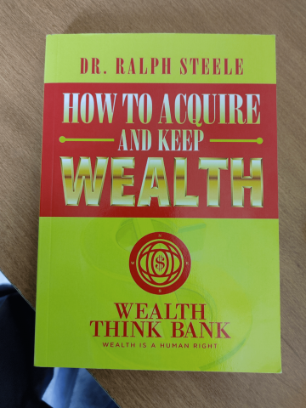
Dr. Ralph has authored 19 books and is a much sought-after speaker by leading businesses, colleges, and universities. He is the host of Wealth Think Tank on the NOW TV network. He was the first African American to host the first Mediation Summit in Kinshasa, Congo. For more information on Wealth Think Tank, visit http://www.wealththinktank.org/
Dr. Ralph Steele has a reputation as an extraordinary expert on wealth building. He says his mission is to educate individuals about economics in both theory and practice. He also wants them to understand critical financial components such as financial literacy, investments, entrepreneurship, business ownership, and financial strategies.
He has also hosted several financial events in Ghana, Africa, and Sydney, Australia. He was one of the leading speakers at the Millionaire Master Plan for Business Entrepreneurs event hosted in Las Vegas, NV.
“Wealth is a human right,” the phrase coined by Dr. Ralph, has become the foundation for creating Wealth Legacy TV in 2019. He has also completed a documentary called “A Cattle on a Thousand Hills.” The subject of the documentary is an economic renewal for inner cities. For more information on Wealth Legacy TV, visit http://www.wealthlegacytelevision.com/
Dr. Steele has helped host various wealth-building conferences and forums. He has hosted many such events for entities such as Capital One Bank, University of Texas Arlington, Richland Community College, Stillman College, Eastfield Community College, Tarrant County Community College, Black CEO Kansas City, KS, and Rolling Hills Country Hills in Arlington, TX.
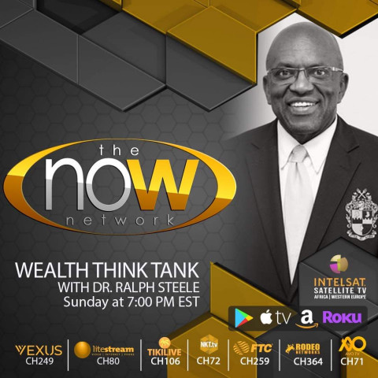
Dr. Steele is a member of Alpha Phi Alpha Fraternity, Inc. and Wealth Think Bank Entrepreneurship and Investment, LLC. The focus is on educating, training, coaching, mentoring, and developing black entrepreneurs.
For more information, visit http://www.wme3cash.com/
About Dr. Ralph Steele
Dr. Steele is a former naval officer, an avid pilot, and a boating expert. He has traveled on all seven continents. He believes the world has the resources and tools to prevent and resolve poverty with creative and engaging policies that include early education in financial literacy and entrepreneurship training. Dr. Steele was rewarded the 2015 Alpha Phi Alpha Fraternity Award for Entrepreneurship of the Year. He is also the recipient of the March 2019 NAACP Award for the Man of Honor and the 2019 Dorothy Norwood Community Services Award. He believes “Wealth is a human right.”
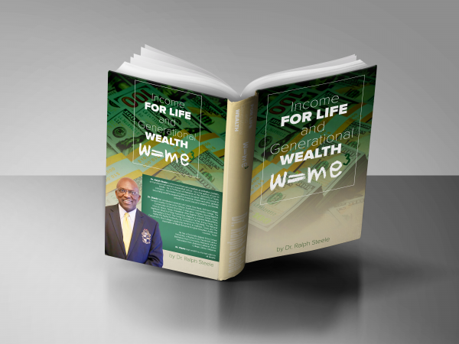
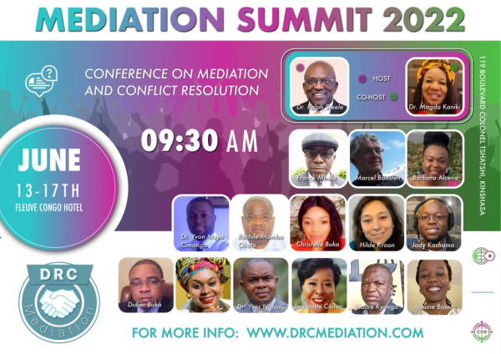

Media Contact
Company Name: Wealth Think Tank
Contact Person: DR RALPH STEELE
Email: rsteele@mediationworlds.com
Phone: 817 729 0543
Address: 602 Magic Mile St
City: Arlington
State: Texas 76011
Country: United States
Website: http://www.wme3cash.com/

